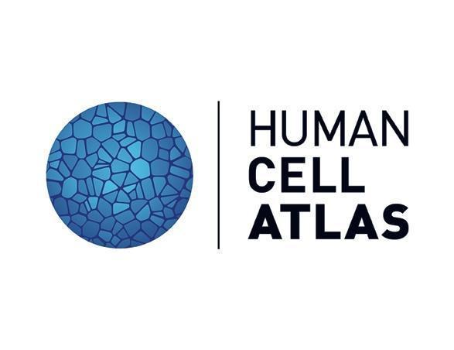

**Speaker Release form for the 2022 Human Cell Atlas** **Latin America Symposium**

**Contact email:** [meetings@broadinstitute.org](mailto:meetings@broadinstitute.org)

This agreement relates to my participation in the Human Cell Atlas (“HCA”) meeting to be held October 6 - 7, 2022.

I understand that the Human Cell Atlas Organizing Committee may wish to use photographs, video and audio recordings (including livestreaming) of the meeting (the “Recordings”) that include images and recordings of me.

I confirm that I grant the Human Cell Atlas Organizing Committee permission to use the Recordings throughout the world for any purposes, in all and any media, including, without limitation, electronic and digital formats, in printed publications, presentations, promotional materials, or on websites, in its original format or edited in such manner as they deem appropriate.

Name (block capitals) IRENE WHITENY

|  |
| --- |
|  |

|  |
| --- |
|  |

Address 940 Winter Street, Waltham MA 02451 USA

|  |
| --- |
|  |

Date September 28thd 2022

|  |
| --- |
|  |