Locking in Carbon and Fighting Climate Change
Wet Planting Days with the Wildlife Trust BCN
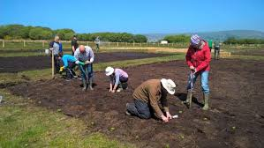
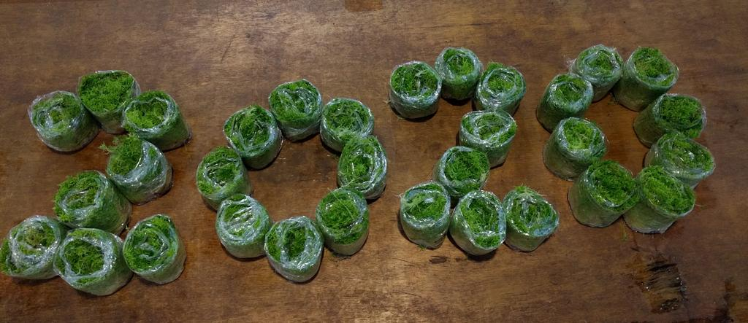

Join us for a great day out at the Great Fen and help us with this ground-breaking project to protect peat soils and reduce greenhouse gas emissions.
Our Wild Work Days are opportunities for corporates to get involved in practical work on our reserves and are very popular with companies and their staff as they provide a great team building experience, getting people outdoors and connected with nature. They also provide opportunities for people to learn more about local nature conservation and the work of the Wildlife Trust. They can also be great for employee health and wellbeing, getting people active and outdoors.

“It was great fun meeting and working with people from other departments.”
“Everyone that attended was full of beans and very energised once back at work”
Participants’ feedback

For this special project we invite groups of up to 30 people at a time to come out and help plant crops which can grow in wet soils and inspire a shift in agricultural practice to a system which will save soil, lock in carbon, clean water and provide food, building materials and medicines. This is physical outdoors work so your team need to be prepared to work hard in all weathers! There are planting days available from April to July where teams will work together with experienced staff and volunteers to plant a range of wetland plants from reeds and flowers to shrubs and sphagnum moss.
The days usually run from 10am to 4pm and we provide all the tools needed to do the job. All your participants need to do is bring a packed lunch and come in appropriate clothing.
We offer ordinarily offer Wild Work Days at a discounted to our Corporate Investor and Partner Members and we charge our Corporate Supporter Members and non-members a standard rate of £50 + VAT per head, but there is no charge for a wet farming planting day. If you would like to book a planting day with us then please do let me know when you are available. We have a range of dates available.
What you can expect from a Wildlife Trust Wild Work Day:
- An exclusive team building experience for groups of various sizes, in a spectacular setting
- All equipment and materials provided
- Task planning and risk assessment
- Expert supervision, guidance and training from our conservation staff
- A fun and rewarding activity, making a real difference to the climate emergency

For further information about our Wild Work Days visit www.wildlifebcn.org/support-us/corporate-support/wild-work-days or email Helen.Daniel@wildlifebcn.org or call her on 01954 713560.

More about the Great Fen and wet farming
The Great Fen is the first of the Wildlife Trusts living landscapes – aiming to join two internationally important National Nature Reserves with 3700ha of reedbeds, fens, flower meadows and grassland. We are already restoring 1200ha and you can see all sorts of new habitats with birds, animals and plants already moving in.
We are building the wet farming project to demonstrate the potential of new crops which fen farmers could grow as an alternative to the drained farming which will caused the loss of all of the peat soil within 80 years – releasing enormous amounts of CO2.
Growing these plants at the Great Fen will also mean we can clean the river water we use to keep our wetlands thriving with a system that pay for itself.
By joining us to plant these amazing plants you will be part of starting a movement to fundamentally change the way we use the countryside forever.

